Verify Check  Cabin  Cleanliness  Seat  Seat belts  Instruments & labeling  Levers / controls  Pedals  Windows / wipers / washers  Rear view mirror  Current registration sticker  Verify Check  Warning signs (in cabin)  SEAT BELTS MUST BE WORN  Warning devices  Verify Check  Horn  Amber flashing beacon (when onsite)  Reversing alarm  Head, tail & turn indicators | Supplier verification & Plant details
 | Plant owner:
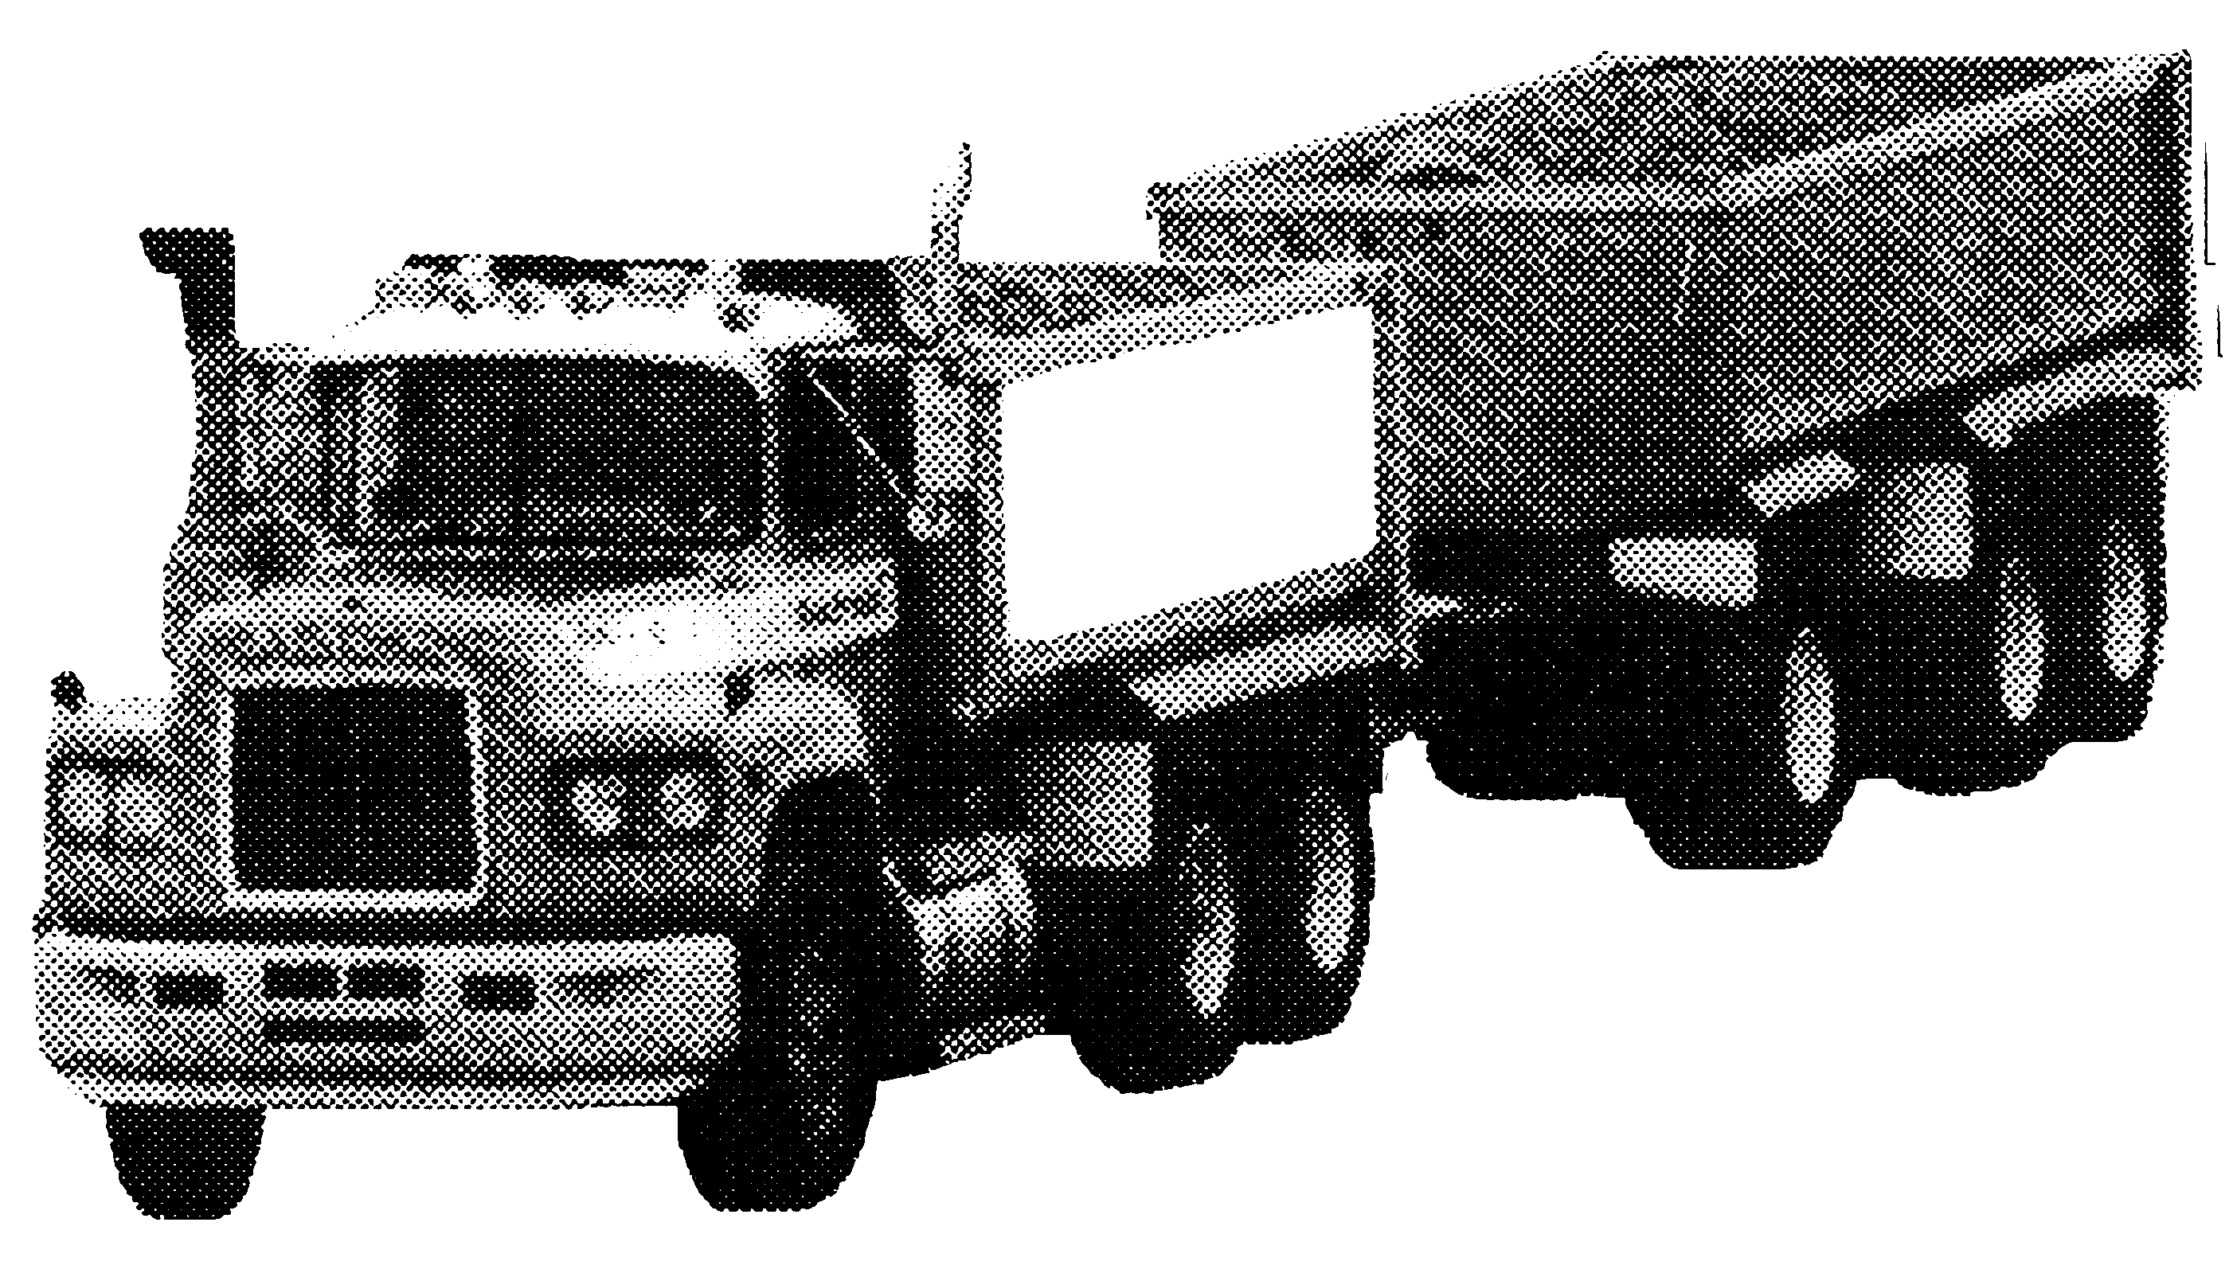 | Address:
 | City/Suburb:
Air / Hydraulics  Verify Check  Rams  Hoses  Connections  (check for excessive wear, leaks and  creep)  Hoist control from cabin  Tail gate control from cabin  Verify Check  Exhaust | Phone:
 | Plant make:
 | Plant model:
Verify Check  KEEP CLEAR  AIR OPERATED TAILGATE | Serial no.:
 | Signature:
 | Date:
 | Road Authority Licence – Articulated Vehicle
Verify Check  Tyres  Wheels  Brakes  Park brake |  Plant to conform to manufacturer’s specifications and Vic Plant Regulations.   Plant operator is to provide daily checksheets to WDA on a weekly basis   Where applicable, Personal Protective Equipment must be worn.   Plant Log Book detailing service history in accordance with Manufacturer’s specifications should be written legibly in English.   Contractor must produce proof of competence of operator, e.g., Certificate of Competence, Licence, detailed Log Book
Verify Check  Connecting rods  Safety pins  (no excessive wear  visible  Towing Hitch | WDA use only
Steering / Tyres  Verify Check  No cuts or splits  Good tread condition  Not recaps  Verify Check  Handrails  Steps | Note: Sign only when all items have been checked
 | Plant check by:
Instructions:  Verify Box to be ticked by Owner / Supplier / Operator prior to arrival onsite.  Check Box to be ticked after visual inspection by WDA | Position:
 | Date: |  | / /

